How to View What Students are Doing- Recordings on Amira

-Click on the reports tab.
- Click on progress report and the students name.
-View the graph above- and scroll down to see the exact lessons. Click on the lesson to view the recording of the lesson.

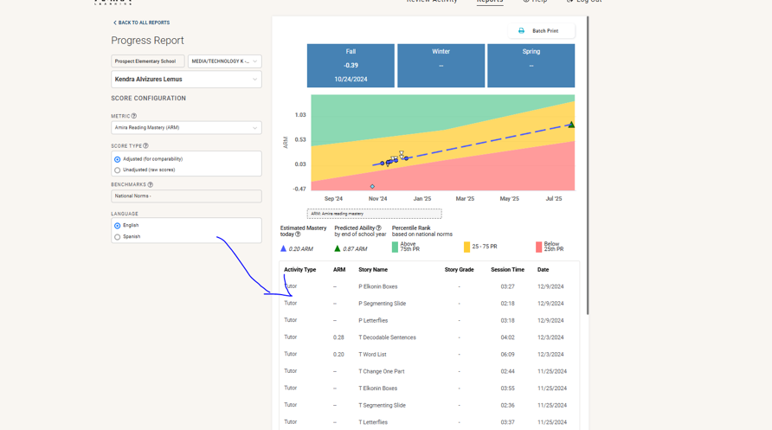

example- you can also listen to the audio

